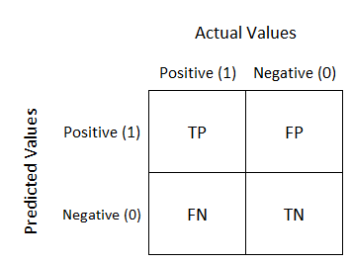
Regression

Confusion Matrix

https://en.wikipedia.org/wiki/Confusion_matrix
https://www.dataschool.io/simple-guide-to-confusion-matrix-terminology

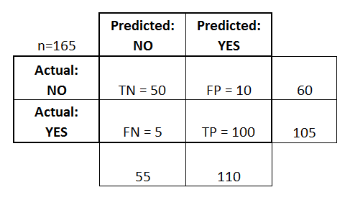
This is a list of rates that are often computed from a confusion matrix for a binary classifier:
- Accuracy: Overall, how often is the classifier correct?
  - (TP+TN)/total = (100+50)/165 = 0.91
- Misclassification Rate: Overall, how often is it wrong?
  - (FP+FN)/total = (10+5)/165 = 0.09
  - equivalent to 1 minus Accuracy
  - also known as "Error Rate"
- True Positive Rate: When it's actually yes, how often does it predict yes?
  - TP/actual yes = 100/105 = 0.95
  - also known as "Sensitivity" or "Recall"
- False Positive Rate: When it's actually no, how often does it predict yes?
  - FP/actual no = 10/60 = 0.17
- True Negative Rate: When it's actually no, how often does it predict no?
  - TN/actual no = 50/60 = 0.83
  - equivalent to 1 minus False Positive Rate
  - also known as "Specificity"
- Precision: When it predicts yes, how often is it correct?
  - TP/predicted yes = 100/110 = 0.91
- Prevalence: How often does the yes condition actually occur in our sample?
  - actual yes/total = 105/165 = 0.64
A couple other terms are also worth mentioning:
- Null Error Rate: This is how often you would be wrong if you always predicted the majority class. (In our example, the null error rate would be 60/165=0.36 because if you always predicted yes, you would only be wrong for the 60 "no" cases.) This can be a useful baseline metric to compare your classifier against. However, the best classifier for a particular application will sometimes have a higher error rate than the null error rate, as demonstrated by the Accuracy Paradox.
- Cohen's Kappa: This is essentially a measure of how well the classifier performed as compared to how well it would have performed simply by chance. In other words, a model will have a high Kappa score if there is a big difference between the accuracy and the null error rate. (More details about Cohen's Kappa.)
- F Score: This is a weighted average of the true positive rate (recall) and precision. (More details about the F Score.)
- ROC Curve: This is a commonly used graph that summarizes the performance of a classifier over all possible thresholds. It is generated by plotting the True Positive Rate (y-axis) against the False Positive Rate (x-axis) as you vary the threshold for assigning observations to a given class. (More details about ROC Curves.)

true positives (TP): These are cases in which we predicted yes (they have the disease), and they do have the disease.
- true negatives (TN): We predicted no, and they don't have the disease.
- false positives (FP): We predicted yes, but they don't actually have the disease. (Also known as a "Type I error.")
- false negatives (FN): We predicted no, but they actually do have the disease. (Also known as a "Type II error.")

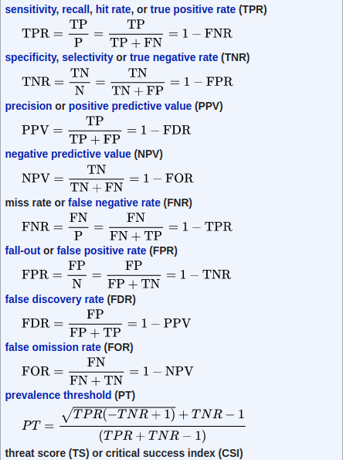

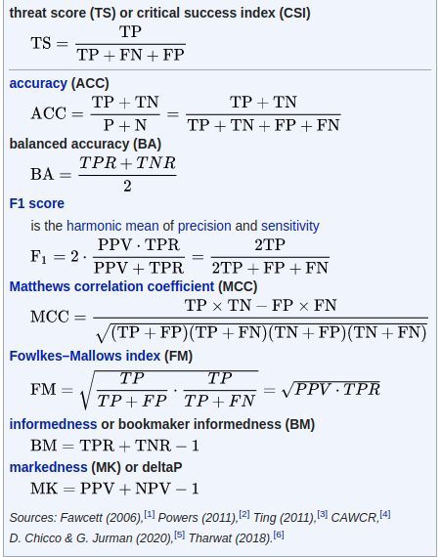

Decision Tree

Entropy
https://www.youtube.com/watch?v=1IQOtJ4NI_0
https://medium.com/analytics-steps/understanding-the-gini-index-and-information-gain-in-decision-trees-ab4720518ba8
It is the measurement of the impurity or randomness in the data points. Entropy is calculated between 0 and 1. Entropy is the lowest (no disorder) at extremes (both end) and maximum (high disorder) in the middle of the graph
